SIMATS ENGINEERING
Department of Computer Science & Engineering
ASSESSMENT TOOL 1-CONSTRAINT-BASED PROBLEM SOL

Course Code: | CSA12 | Course Title: | Computer Architecture for Multicore Systems
CO Assessed: | CO5 | Assessment: | ASSESSMENT TOOL1-  Constraint-Based  Problem Solving
Weightage: | 40% | Total Marks: | 25
CO5 Statement: | Construct I/O communication mechanisms by comparing memory-mapped and  I/O-mapped techniques, interrupt handling (vectored, hardware, software), DMA controllers, and advanced bus interfaces including PCIe, USB, NVMe, and Thunderbolt.
Student Name: | M.Dinesh kumar | Reg.No.: | 192525298
Department: | CSE | Date: | 31/8/2026

ANNEXURE A
Constraint-Based Problem Solving
1.Construct an I/O communication mechanism for a real-time embedded system with the following constraints:
- CPU utilization must be below 15%
- Multiple sensors generate interrupts every 1 ms
- Use vectored interrupt handling
- Select between memory-mapped and I/O-mapped I/O for optimal latency
2.Design an I/O subsystem under these constraints:
- High-speed storage requires throughput > 3 GB/s
- Must use NVMe over PCIe
- CPU should not handle bulk data transfer
- Integrate DMA controller with interrupt notification
3.Construct a multi-device communication architecture with constraints:
- 6 peripherals using USB, 2 high-speed devices using Thunderbolt
- Avoid interrupt starvation
- Use hardware and software interrupts
- Ensure fair bus arbitration
4.Design a data acquisition system with constraints:
- Continuous data stream at 500 MB/s
- Minimal CPU intervention required
- Must compare DMA transfer vs interrupt-driven I/O
- Use memory-mapped I/O for device registers
5.Construct an interrupt handling mechanism with constraints:
- Support nested interrupts
- Maximum interrupt latency < 10 µs
- Use vectored interrupts for high-priority devices
- Use software interrupts for background tasks

Code of Conduct:

I M.Dinesh kumar(192525298)(Name / Reg No) certify that this submission is my original work and that I have adhered to the guidelines specified for this assessment.
I understand that any violation of academic integrity rules will result in disciplinary action.

Signature of the student: M.Dinesh kumar

MARKS ALLOCATION
 | Problem  Understanding  (25%) | Constraint Analysis (25%) | Solution  Development  (25%) | Application of Concepts  (15%) | Justification  (10%)
Q1
Q2
Q3
Q4
Q5

RUBRICS FOR CALCULATION:

Criteria | Weightage | Level 4 – Exemplary | Level 3 – Proficient | Level 2 –  Developing | Level 1 –  Beginning
Problem Understanding | 25% | Clearly defines the problem and identifies all relevant constraints accurately | Identifies most constraints with minor gaps | Partial understanding; misses key constraints | Fails to identify constraints correctly
Constraint Analysis | 25% | Analyzes constraints effectively and prioritizes them logically | Provides reasonable analysis with some prioritization | Limited analysis; weak  prioritization | No meaningful analysis or prioritization
Solution Development | 25% | Develops optimal and feasible solutions  satisfying all constraints | Develops workable solutions with minor limitations | Solutions partially satisfy constraints | Solutions do not meet constraints
Application of Concepts | 15% | Effectively applies appropriate concepts, methods, or tools | Applies concepts with minor errors | Limited application; requires guidance | Unable to apply relevant concepts
Justification | 10% | Provides strong justification for decisions with logical reasoning | Provides justification with some clarity | Weak or unclear justification | No justification provided

1. Proposed I/O Communication Mechanism
- Every sensor generates an interrupt every 1 ms.
- The interrupt controller receives the interrupt.
- Because vectored interrupt handling is used, the controller directly identifies the corresponding ISR address.
- The ISR should be very short:
  - Identify the sensor.
  - Read the sensor data.
  - Store it in a ring buffer.
  - Clear/acknowledge the interrupt.
  - Return immediately.
- The main application processes the buffered sensor data outside the ISR.
This prevents lengthy processing from occurring inside the interrupt routine.
2. Vectored Interrupt Handling
With vectored interrupts, each sensor/interrupt source has its own vector.
Interrupt Vector Table

Vector 0 → Sensor 1 ISR
Vector 1 → Sensor 2 ISR
Vector 2 → Sensor 3 ISR
.
.
Vector N → Sensor N ISR
When Sensor 2 generates an interrupt:
Sensor 2
↓
Interrupt Controller
↓
Vector 2
↓
Sensor 2 ISR
↓
Read data
↓
Store in buffer
↓
Return

Advantage
The CPU does not need to poll every sensor to determine which one generated the interrupt.
Therefore:
- Lower interrupt latency
- Faster response
- Less CPU overhead
- Suitable for real-time systems

3. Memory-Mapped vs I/O-Mapped I/O
We need to select the method that provides the best latency.

Memory-Mapped I/O
Sensor registers are assigned normal memory addresses.
Sensor Data Register → 0x40001000
Sensor Status Register → 0x40001004
CPU can access them using normal load/store instructions.
Example:
data = *(volatile int *)0x40001000;

I/O-Mapped I/O
I/O devices have a separate I/O address space.
Special instructions are generally required:

2 . High-Speed NVMe I/O Subsystem

Given Constraints
- Storage throughput must be greater than 3 GB/s.
- NVMe over PCIe must be used.
- CPU should not perform bulk data transfers.
- DMA must be integrated with interrupt notification.

Problem Understanding
The system requires very high-speed storage communication. Moving every byte through the CPU would create significant CPU overhead. Therefore, a high-speed PCIe connection and DMA-based data transfer are required.

Constraint Analysis
- Throughput > 3 GB/s: Requires a high-bandwidth interface.
- NVMe over PCIe: NVMe provides efficient communication with highspeed SSDs.
- Low CPU involvement: Bulk data must bypass the CPU.
- DMA + interrupt: DMA performs transfer while interrupts notify the CPU after completion.

Solution Development
An NVMe SSD connected through PCIe with DMA is selected.
The CPU creates an NVMe command and places it in the command queue. The NVMe controller communicates through PCIe. DMA transfers data directly between the NVMe SSD and main memory.
After the transfer is completed, an interrupt is generated to notify the CPU.
Diagram:
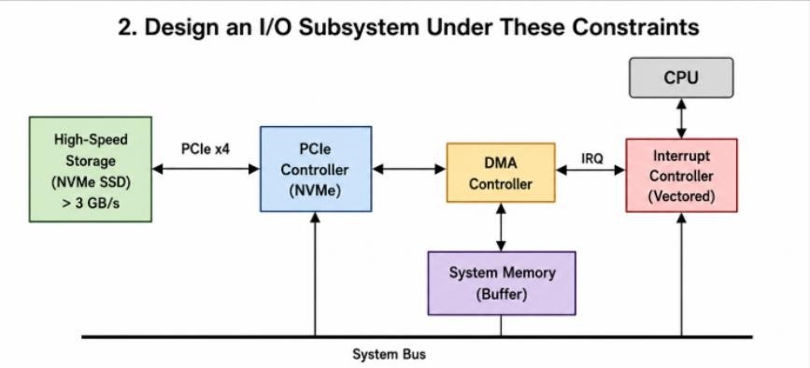

Data Flow
CPU → NVMe Command Queue → PCIe → NVMe SSD
NVMe SSD → DMA → Main Memory
DMA Completion → Interrupt → CPU

Role of DMA
Without DMA:
NVMe → CPU → Memory
The CPU must participate in data movement.
With DMA:
NVMe → DMA → Memory
The CPU only controls the operation and handles completion notifications.

Justification
DMA is selected because the CPU does not need to copy large amounts of storage data. PCIe provides the required high-speed communication path, while NVMe provides efficient command queues for SSD operations.

Conclusion
The best solution is NVMe + PCIe + DMA + interrupt notification, which provides high throughput while keeping CPU involvement low.

Multi-Device USB and Thunderbolt Communication Architecture

Given Constraints
- Six peripherals must use USB.
- Two high-speed devices must use Thunderbolt.
- Interrupt starvation must be avoided.
- Hardware and software interrupts must be supported. • Fair bus arbitration must be ensured.

Problem Understanding
The system contains eight devices using two different communication technologies. Thunderbolt devices require high-speed communication, while USB devices also need regular access. A suitable priority and arbitration mechanism is required so that no device waits indefinitely.

Constraint Analysis
- 6 USB devices: Connected through a USB host controller.
- 2 Thunderbolt devices: Connected through a Thunderbolt controller.
- Interrupt starvation: Low-priority devices must also receive service.
- Hardware interrupts: Used for actual device events.
- Software interrupts: Used for deferred/background operations. • Fair arbitration: Bus access must be shared among devices.

Solution Development
The six USB peripherals are connected to a USB host controller.
The two high-speed devices are connected to a Thunderbolt controller.
A priority-based arbitration mechanism is used. Thunderbolt devices can receive higher priority when required, but USB devices are given guaranteed service using round-robin scheduling and aging.

Diagram:
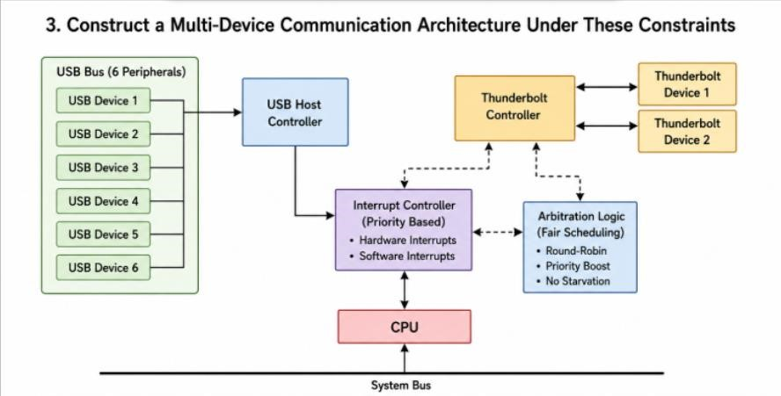

Arbitration
USB1 → USB2 → USB3 → USB4 → USB5 → USB6 → Repeat
If a USB device waits for too long, its priority is increased so that it cannot be permanently blocked.

Interrupt Handling
- Hardware interrupts: Device events such as data arrival, errors, or connection changes.
- Software interrupts: Background processing, deferred tasks, and operatingsystem services.
- Priority mechanism: Critical events are handled first.
- Round-robin: Provides fair access among devices of similar priority.

Justification
Using only fixed priority could cause USB devices to suffer starvation. Using only round-robin could delay important Thunderbolt operations. Therefore, a priority + fairness mechanism provides both fast response and fair bus access.

Conclusion
The proposed system uses USB + Thunderbolt + hardware/software interrupts + priority scheduling + round-robin arbitration to provide reliable and fair communication.

Data Acquisition System – 500 MB/s

Given Constraints
- Continuous data stream of 500 MB/s.
- Minimal CPU intervention.
- DMA transfer must be compared with interrupt-driven I/O. • Device registers must use memory-mapped I/O.

Problem Understanding
The data acquisition device continuously produces data at 500 MB/s. If the CPU handles every data item, CPU utilization will become very high. Therefore, an autonomous data-transfer mechanism is required.

Constraint Analysis
- 500 MB/s: Requires high-speed continuous data transfer.
- Minimal CPU intervention: CPU should not copy data.
- DMA comparison: DMA should be evaluated against interrupt-driven I/O.
- Memory-mapped I/O: Device registers are accessed through memory addresses.

Solution Development
The recommended solution is memory-mapped I/O + DMA + double buffering.
The CPU configures the DMA controller with:
- Source address
- Destination address
- Transfer size
DMA then transfers data directly from the acquisition device to memory.
Diagram:
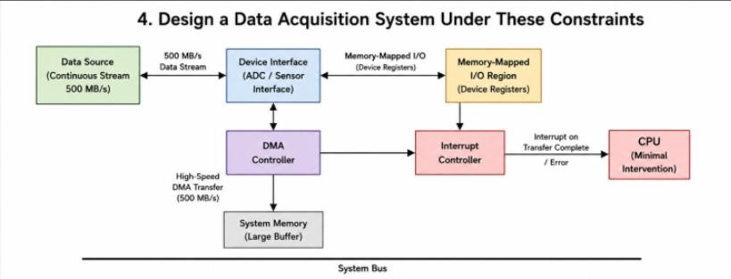

Data Flow
Data Acquisition Device → DMA Controller → Buffer A / Buffer B → CPU
While DMA fills Buffer A, the CPU processes Buffer B. After Buffer A becomes full, the roles are exchanged.

DMA vs Interrupt-Driven I/O
Parameter | DMA | Interrupt-Driven I/O
CPU involvement | Very low | High
Data movement | Device → Memory | Device → CPU → Memory
Suitable for 500 MB/s | Yes | No
Interrupt frequency | Block-based | Very high
CPU overhead | Low | High
Performance | High | Lower

Justification
At 500 MB/s, generating an interrupt for every small data unit would create an extremely large number of interrupts. DMA can transfer large blocks and generate only a completion interrupt, greatly reducing CPU overhead.

Conclusion
Memory-mapped I/O + DMA + double buffering is the most suitable solution for continuous 500 MB/s data acquisition.

Nested Interrupt Handling Mechanism

Given Constraints
- Nested interrupts must be supported.
- Maximum interrupt latency must be less than 10 µs.
- Vectored interrupts must be used for high-priority devices. • Software interrupts must be used for background tasks.

Problem Understanding
A high-priority interrupt may occur while the CPU is already processing a lowerpriority interrupt. The system must temporarily suspend the lower-priority ISR, service the important interrupt, and then return to the previous ISR.

Constraint Analysis
- Latency < 10 µs: Interrupt dispatch must be very fast.
- Nested interrupts: Higher-priority interrupts must preempt lower-priority ISRs.
- Vectored interrupts: Directly identify the required ISR.
- Software interrupts: Used for non-critical background operations.
Diagram:
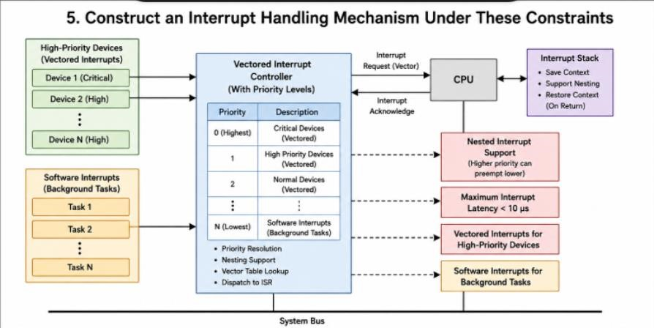

Solution Development
A priority-based nested interrupt controller is used.
When an interrupt occurs, the controller checks its priority. A high-priority interrupt is immediately directed to its corresponding ISR using a vector.
If a higher-priority interrupt arrives while another ISR is executing:
Low Priority ISR → High Priority Interrupt → High Priority ISR → Return → Low Priority ISR
The CPU saves the current ISR context before executing the higher-priority ISR.

Priority Structure
Priority | Task
1 | Emergency / Real-Time Device
2 | High-Speed I/O
3 | Normal I/O
4 | Background Tasks
Reducing Interrupt Latency To maintain latency below 10 µs:
- Use vectored interrupts.
- Keep ISRs short.
- Use priority-based preemption.
- Minimize interrupt masking.
- Save and restore CPU context efficiently.
- Move lengthy processing to software/deferred interrupts. • Use DMA for large data transfers.

Software Interrupts
Software interrupts are used for:
- Background processing
- Logging
- Deferred cleanup
- Task signaling
They are given lower priority so they do not interfere with critical hardware interrupts.

Conclusion
A nested, priority-based vectored interrupt system provides fast response to critical devices while software interrupts handle background activities. This design helps maintain the required less than 10 µs interrupt latency.

